New Mexico Chronic Homelessness Documentation Packet
Developed by the New Mexico Coalition to End Homelessness
Updated June 2017

Index

- Chronically Homeless Status Checklist…………………………………………………………………………………………2
- Chronically Homeless Timeline Checklist…………………………………………………………………………………….5
- Template Letter for Requesting Third Party Documentation from an Emergency Shelter……………7
- Certification of Homelessness from a Third Party Housing or Service Provider……………………………8
- Documentation of Verbal Third Party Verification from a Housing or Service Provider……………….9
- Certification of Homelessness from a Community Member………………………………………………………10
- Documentation of Verbal Third Party Verification from a Community Member………………………..11
- Chronic Homelessness Self Certification……………………………………………………………………………………12
- Record of Due Diligence to Obtain Third Party Documentation and to House a Chronically Homeless Household…………………………………………………………………………………………………………………14
- Using HMIS to Document Homelessness………………………………………………….……………………………….16

Chronically Homeless Status Checklist
This checklist is a cover sheet for documenting the “chronically homeless” status for applicants of Continuum of Care (CoC) Permanent Supportive Housing (PSH) programs. This checklist should be accompanied by supporting documentation of both disability and homelessness. Together, these documents must be maintained in the client’s file.
Applicant name:
PSH Program that the applicant is applying for:
Date of housing-related first contact:
Name of staff person completing this form:
Date this form was completed:

CHRONIC HOMELESS STATUS
An individual (including a minor) or an adult head of household (or if there is no adult in the family, a minor head of household) who meets the following criteria is chronically homeless.

- First, the applicant must meet one of these criteria (check one):
____Currently living in an emergency shelter or a place not meant for human habitation (i.e. a park or car)
OR

__Currently in an institution (i.e. mental health facility, prison, hospital) but has been there less than 90 days and was living in a shelter or place not meant for human habitation immediately prior to entering the institution

- Then the applicant must also meet one of these criteria (check one):
___ Has been continuously homeless for 12 months or more. Homeless means living in an emergency shelter or in a place not meant for human habitation (i.e. in a park or car).

If the individual is in an institution, this does not count as a “break” in the 12 months if he/she has been there less than 90 days and was living in a shelter or place not meant for human habitation immediately prior to entering the institution.
OR

_____Has had at least 4 episodes of homelessness in the last 3 years, with the cumulative total of the 4 episodes at least 12 months and each episode separated by a break of at least 7 consecutive nights. Homeless means living in an emergency shelter or in a place not meant for human habitation (i.e. in a park or car). A “break” means that the person was not living in an emergency shelter or place for human habitation, but instead had some form of housing (i.e. a motel he/she paid for, staying with a family member or in his/her own apartment).
- Finally, the applicant must have a documented disability.
Does the applicant have a documented disability? (Please see pg. 3 for qualifying documentation). ____ Yes ____ No
DOCUMENTATION OF CHRONIC HOMELESSNESS
Please complete the Chronic Homelessness Timeline/Documentation Checklist (see pages 4-5 of this packet) with the applicant, which includes the date and location of each episode of homelessness. Each episode of homelessness must be verified by one of the following listed below. In addition, if the applicant meets the definition of chronic homelessness because he/she had 4 or more episodes, you must also document that there was at least a 7-day break between episodes. Please check each type of documentation that you have:

____ Letter or recorded oral statement from another housing or service provider
____ Letter or recorded oral statement from an outreach worker describing conditions where the individual/family was living
____ Letter or recorded oral statement from a community member describing conditions where the individual/family was living
____An HMIS Record using HMIS “screenshots” that shows the applicant’s name, name of emergency shelter and entry and exit dates into the shelter.
____ Self-Certification Statement signed by the client. Only 25% of a PSH program’s participants can use self-certification to document more than 3 months of homelessness. However, there is no limit on how many breaks of at least 7 days can be documented via self-certification.
___If the applicant stayed in/is coming from an institution:

___ Discharge paperwork or a written or oral referral from a social worker, case manager, or other appropriate official of the institutional care facility stating the beginning and end dates of the time residing in the institutional care facility. All oral statements must be recorded by the intake worker.
___If this is not obtainable, then include a written record of the intake worker’s due diligence in attempting to obtain that evidence and a certification by the individual seeking assistance that states that he/she is exiting or has just exited an institutional care facility where he or she resided for fewer than 90 days

IMPORTANT NOTES ABOUT DOCUMENTATION:
- All documentation must specifically state the dates that the applicant was homeless and must state that the applicant was sleeping in a shelter or in a place not meant for human habitation (i.e. the letter must state that the client was “sleeping in a park” not simply that he was “homeless.”)
- Third-party documentation of a single encounter with a homeless service provider on a single day within 1 month is sufficient to consider an individual as homeless and living or residing in a place not meant for human habitation or an emergency shelter for the entire calendar month unless there is evidence that there was a 7 night “break” during that month.
DOCUMENTATION OF DISABILITY
To document disability, the applicant must have one of the following. Please check which type of documentation you have.
____ Written verification of the disability from a professional licensed by the state to diagnose and treat the disability. The certification should state that the disability is expected to be long-continuing or of indefinite duration and substantially impedes the individual’s ability to live independently. The licensed professional should sign the verification and include his/her credentials.
_____Written verification from the Social Security Administration
_____Receipt of a disability check (e.g., Social Security Disability Insurance check)
_____Intake staff-recorded observation of disability that, no later than 45 days from the application for assistance, is confirmed and accompanied by evidence listed above

Note: Documentation from the Social Security Administration should show that the applicant is receiving disability related benefits, i.e. SSI or SSDI.
Chronic Homelessness Timeline Checklist
Applicant:
Name of staff person completing this form:
Date completed:
This worksheet tracks the timeline of homelessness for a Permanent Supportive Housing applicant. Please work with the applicant to complete this timeline to ensure that the applicant meets HUD’s definition of “chronically homeless,” as indicated on the first page of this packet.
Note that for applicants with at least 4 episodes of homelessness, you must also list and document that there was a break between each episode of homeless of at least 7 consecutive nights.
Time Period | Where the Applicant was Sleeping | Verification/Due Diligence Documentation | Documentation is Attached
Example: Jan.1-31, 2016 | Albuquerque Rescue Mission Winter Shelter | Yes- Letter from shelter | Yes
Example: February 1 – 15, 2016 | Stayed with sister at her house in Albuquerque | Yes – Self-certification from client. Completed Due Diligence form showing sister did not return calls | Yes
Example: February 16 – March 10, 2016 | Stayed in his car | Yes – Letter from outreach worker | Yes
Time Period | Where the Applicant was Sleeping | Verification/Due Diligence Documentation | Documentation is Attached

Does this chart show 12 consecutive months of homelessness or 4 episodes of homelessness with breaks of at least 7 consecutive nights between episodes? ______ Yes ______ No

Template Letter for Requesting Third Party Document from an Emergency Shelter
To:

Dear _______________________,

_____________________________, DOB_______ has applied for housing assistance through our Permanent Supportive Housing Program. To qualify, the applicant must be determined to be “chronically homeless“as defined by the U.S. Department of Housing and Urban Development.
The applicant has indicated that he/she has received shelter services at your organization in the past. On your organization’s letterhead, please list all shelter dates for the applicant.
Please fax it to my attention as soon as possible at add fax number.
This information will be used for the purpose of determining the chronic homeless status for the above-named applicant. If you have any questions please do not hesitate to contact me at telephone number: (______)__________. Thank you for your time and consideration.
Sincerely,

*Name/Title*

Applicant Release: I, ____________________hereby authorize the release of the requested information.
______________________________________________ ___________________
Applicant Signature Date

Certification of Homelessness from a Third Party Housing or Service Provider

(Print form on third party agency letterhead if available.)
I have personally encountered_________________________________ (name of applicant) and believe,based on my professional judgment, the applicant was living in a shelter or place not meant for human habitation at the time that I personally encountered the applicant. Below are the details of my encounters with _______________________________________ (name of applicant).
Date of Interaction | Brief Description of Interaction | Where the Applicant was Living at that Time (please be specific)
Ex 1: May 9, 2016 | (Name of applicant) came into the day shelter to get help obtaining an ID | (Name of applicant) was sleeping in his car
Ex 2: June 2, 2016 | (Name of applicant) came in to get a meal and talked with staff for a few minutes. | (Name of applicant) was sleeping in a park

__________________________________________
Signature of third party verifier

__________________________________________
Printed name of third party verifier

__________________________________________
Title

________________________________
Date
Documentation of Verbal Third Party Verification from a Housing or Service Provider
(to be used when written verification cannot be obtained)

I certify that I spoke with _______________________________________ (Name) with ______________________________________________ (third party agency). They verified that they had personally encountered _________________________________________ (name of applicant) and based on their professional judgement, the applicant was living in a shelter or place not meant for human habitation at the time they personally encountered the applicant. The specific information provided by the third party agency is described below:

Date of interaction | Brief description of interaction | Where the applicant was living at that time (be specific)
Ex 1: May 9, 2016 | (Name of applicant) came into the day shelter to get help obtaining an ID | (Name of applicant) was sleeping in his car
Ex 2: June 2, 2016 | (Name of applicant) came in to get a meal and talked with staff for a few minutes. | (Name of applicant) was sleeping in a park
__________________________________________________
Name of staff person who obtained the verbal verification

___________________________________________________ ________________
Signature Date

__________________________________________
Title
Certification of Homelessness from a Community Member
(print form on third party agency letterhead if available)
I have physically observed _________________________________ (name of applicant) living in a place not meant for human habitation on the dates listed below. I know or am familiar with ____________________________________ (name of applicant) because________________________
_____________________________________________________________________________________

Date I physically observed the applicant | Brief description where I physically observed the applicant was staying
Ex 1: May 9, 2016 | (Name of applicant) was sleeping outside in a park
Ex 2: June 2, 2016 | (Name of applicant) was sleeping in his car

__________________________________________
Signature of third party verifier

__________________________________________
Printed name of third party verifier

__________________________________________
Title

________________________________
Date
Documentation of Verbal Third Party Verification from a Community Member

(To be used when written verification cannot be obtained.)

I certify that I spoke with ______________________________________ (name of community member). They verified that they had physically observed _______________________________________ (name of applicant) staying in place not meant for human habitation at the time they personally encountered the applicant. The specific information provided by the Community Member is described below. The community member knows or is familiar with _________________________ (name of applicant) because___________________________________________________________________________________________________________________________________________________________________
Date community member physically observed the applicant | Brief description where the community member physically observed the applicant was staying
Ex 1: May 9, 2016 | (Name of applicant) was sleeping outside in a park
Ex 2: June 2, 2016 | (Name of applicant) was sleeping in his car
__________________________________________________
Name of staff person who obtained the verbal verification

___________________________________________________ ________________
Signature Date

__________________________________________
Title
Chronic Homelessness Self Certification

This form may be used when the PSH program cannot obtain third party verification of homelessness to document 12 months of homelessness. If the applicant meets the definition of homelessness because he/she had at least 4 episodes of homelessness, this form can also be used to document that there was a break of at least 7 consecutive nights between each episode. Important note: All applicants can document up to 3 months using self-certification. However, only 25% of a PSH program’s total participants can use self-certification to document more than 3 months. This form must be signed and dated by the applicant in order to be valid.
I certify that I was homeless (that is sleeping in a place not meant for human habitation (such as living on the streets) OR living in a homeless emergency shelter during the following periods of time:
Ex. Between: ________Jan. 2015 and August 2015____ I lived at In my car_________________
Between: ________________and _______________I lived at ____________________________
Between: ________________and _______________I lived at ____________________________
Between: ________________and _______________I lived at ____________________________
Between: ________________and _______________I lived at ____________________________
Between: ________________and _______________I lived at ____________________________
Between: ________________and _______________I lived at ____________________________
Between: ________________and _______________I lived at ____________________________
If I meet the definition of chronic homelessness because I have had at least 4 episodes of homelessness, I certify that there was a break of at least 7 consecutive nights between each episode as listed below. A “break” means that I was not staying in an emergency shelter or place not meant for human habitation, but instead had some form of housing (i.e. staying with a family member).
Ex. Between: ____ Sept. 2015 and October 2015___ I lived at My sister’s house______________
Between: ________________and _______________I lived at ____________________________
Between: ________________and _______________I lived at ____________________________
Between: ________________and _______________I lived at ____________________________
Between: ________________and _______________I lived at ____________________________
Between: ________________and _______________I lived at ____________________________
What else would you like to say about your history? For example, “I cannot remember the names of the places that I was living in the Fall of 2004, but I believe it was in a homeless emergency shelter. I have problems with my memory from that time due to an illness.”
______________________________________________________________________________
______________________________________________________________________________
______________________________________________________________________________
I certify that the above information is correct.
____________________________________
Name of Client

____________________________________ _______________
Signature of Client Date

I reviewed the above statement with the client.

_____________________________________
Name of Staff Person

_____________________________________ _______________
Signature of Staff Person Date

______________________________________
Title

Record of Due Diligence to Obtain Third Party Documentation and to House a Chronically Homeless Household

This form can be used to document two types of due diligence:

Due Diligence to Obtain Third Party Documentation
The PSH program must use and document due diligence to obtain third party documentation of chronic homelessness before using the self-certification form.
Due Diligence to House a Chronically Homeless Household
When a PSH program has an upcoming opening for dedicated or prioritized chronic homeless bed(s), the program must use due diligence to find and house a chronically homeless household through the NM Coordinated Assessment System. If the program is not able to identify a chronically homeless household within 14 days of the bed becoming available, the program should proceed with filling the bed(s) with a non-chronically homeless household using the process in the CoC Common Standards. In this case, the PSH program must document its due diligence to find and house a chronically homeless household using this form.
Name of Permanent Supportive Housing Program:
Date that chronic homeless dedicated or prioritized bed(s) became available:
Intake staff have taken these steps to obtain third party documentation for the applicant(s) listed below and/or have taken these steps to contact the potential applicant(s) listed below and establish their chronic homelessness. The potential applicant(s) have been referred to the PSH program through the NM Coordinated Assessment System because they appear to be chronically homeless.
Name of Potential Applicant  (from Coordinated Assessment System) | Steps taken to obtain third party documentation and/or to contact the potential applicant and establish their chronic homelessness | Dates
Ex: Joe Smith | Attempted to obtain third party verification, but third party provider did not return phone calls. | 5/3/16-5/6/16
Ex: Mary Martinez | Left 3 voicemail messages at the phone number listed for Mary Martinez, but did not receive return phone call | 5/6/16-5/8/16

The information provided in this written statement is true and complete to the best of my knowledge.
________________________________________
Name of Staff Person

________________________________________ _______________________
Signature of Staff Person Date

________________________________________
Title

Using HMIS to Document Homelessness
You must complete two steps:
1) Produce an HMIS screen shot showing the emergency shelter stay
2) Produce a Client Event Report
How to produce an HMIS screen shot showing emergency shelter stay:
- Log in to HMIS
- Use client name or HMIS ID to retrieve and open the client’s record
- Under CLIENT INFORMATION, select the ENTRY/EXIT Tab
- Confirm that the following information is visible on the screen:
- Applicant’s Name
- Name of Program
- Program Entry and Exit Dates
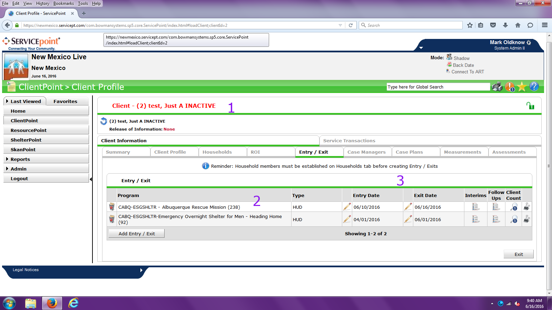
5. Press the PRT SCR key on your keyboard, usually located somewhere on the top row of keys
6. WITHOUT ANY INTERVENING STEPS, Open MS Word (or some other compatible software program), select the EDIT key and click on the PASTE command
7. Print (or save) the resulting document and place in client’s program file.

How to produce a Client Event History Report in NM HMIS:
Log in to ServicePoint, and go to (click on) REPORTS. Go to ART.
- In the ART directory, open the PUBLIC FOLDER. In the Public Folder, open the COC & MFA subdirectory.
- Select the 409 – CLIENT EVENT HISTORY report. There is only one user prompt, enter the desired HMIS CLIENT ID.
- Save the report. Print in hardcopy and retain in client file. Specifically, be sure to print and retain the CLIENT TRANSACTION DETAIL tab information. Update as needed based on changes to client project status in project.
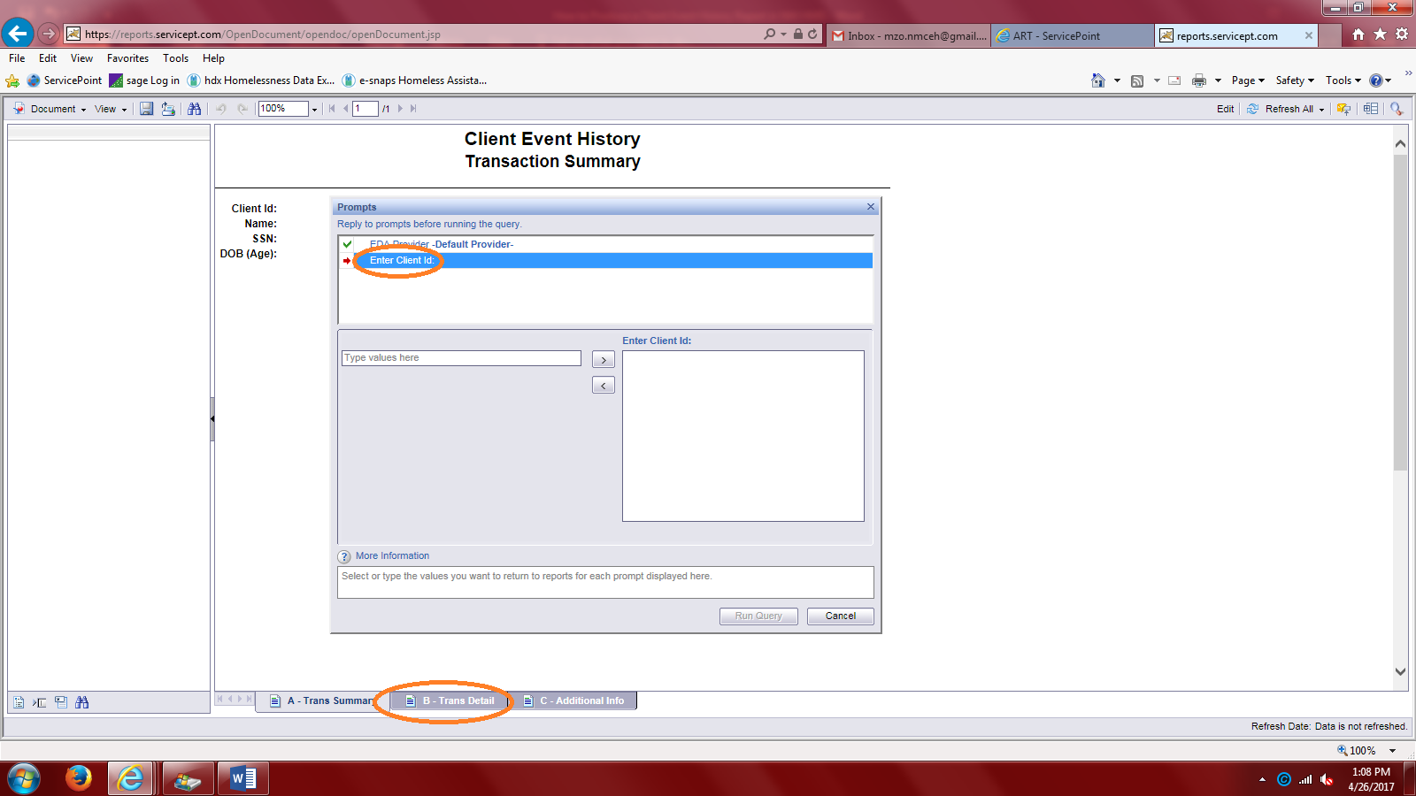

If you have questions or if HUD ever requests additional information pertaining to client record history, contact NM HMIS at (505) 982-9000.

